**WORKSHEET-1**

**DEEP LEARNING**

**Q1 to Q8 are MCQs with only one correct answer. Choose the correct option.**

1. Which of the following can approximate any function universally (i.e. universal approximators)?

**Answer:** D) All of the above

2. In which of the following domains we cannot use neural networks?

**Answer:** D) None of the above

3. Rearrange the following steps of a gradient descent algorithm in correct order of their occurrence?

i. Initialize random weight and bias

ii. Repeat the process until you find the best weights of network

iii. Change weights and biases for each neuron to reduce the error

iv. Calculate error distances between the actual and the predicted value

v. Pass an input through the network and get values from output layer

Choose the correct option:

**Answer:** C) i – v – iv – iii – ii

4. What is the full form of RNN?

**Answer:** A) Recurrent Neural Network

5. What is plasticity in neural networks?

**Answer:** A) input pattern keeps on changing

6. What is stability plasticity dilemma?

**Answer:** AC) dynamic inputs & categorization can’t be handled

7. Read the following statements:

Statement 1: It is possible to train a network well by initializing all the weights as 0

Statement 2: It is possible to train a network well by initializing biases as 0

Which of the statements given above is true, Choose the correct option?

**Answer:** B) Statement 2 is true while statement 1 is false

8. Which of the following architecture has feedback connections?

**Answer:** A) Recurrent Neural network

**Q9 and Q10 are MCQs with one or more correct answers. Choose all the correct options.**

9. In training a neural network, you notice that the loss does not decrease in the few starting epochs. The reason behind it could be

**Answer:** A) Learning Rate is low B) Regularisation parameter is high D) Stuck at local minima

10. Which of the following function(s) can be used to impart non – linearity in a neural network?

**Answer:** B) Rectified Linear Unit

**Q11 to Q15 are subjective answer type question. Answer them briefly.**

11. What is Deep Learning?

**Answer:** The field of artificial intelligence is essentially when machines can do tasks that typically require human intelligence. It encompasses machine learning, where machines can learn by experience and acquire skills without human involvement.

Deep learning is a subset of machine learning where artificial neural networks, algorithms inspired by the human brain, learn from large amounts of data. Similar, to how we learn from experience, the deep learning algorithm would perform a task repeatedly, each time tweaking it a little to improve the outcome. We refer to ‘deep learning’ because the neural networks have various (deep) layers that enable learning. Just about any problem that requires thought to figure out is a problem deep learning can learn to solve.

Since deep-learning algorithms require a ton of data to learn from, this increase in data creation is one reason that deep learning capabilities have grown in recent years. In addition to more data creation, deep learning algorithms benefit from the stronger computing power that’s available today as well as the proliferation of Artificial Intelligence (AI) as a Service.

12. What is reinforcement learning?

**Answer:** Reinforcement learning is a machine learning training method based on rewarding desired behaviors and/or punishing undesired ones. In general, a reinforcement learning agent is able to perceive and interpret its environment, take actions and learn through trial and error.

In reinforcement learning, developers devise a method of rewarding desired behaviors and punishing negative behaviors. This method assigns positive values to the desired actions to encourage the agent and negative values to undesired behaviors. This programs the agent to seek long-term and maximum overall reward to achieve an optimal solution.

Reinforcement learning is an approach to machine learning that is inspired by behaviorist psychology. It is similar to how a child learns to perform a new task. Reinforcement learning contrasts with other machine learning approaches in that the algorithm is not explicitly told how to perform a task, but works through the problem on its own.

As an agent, which could be a self-driving car or a program playing chess, interacts with its environment, receives a reward state depending on how it performs, such as driving to destination safely or winning a game. Conversely, the agent receives a penalty for performing incorrectly, such as going off the road or being checkmated.

The agent over time makes decisions to maximize its reward and minimize its penalty using dynamic programming. The advantage of this approach to artificial intelligence is that it allows an AI program to learn without a programmer spelling out how an agent should perform the task.

13. What Are the Differences Between Machine Learning and Deep Learning?

**Answer:** There are various factors on basis of which we can compare these:

1. **Functioning:** Deep learning is a subset of machine learning that takes data as an input and makes intuitive and intelligent decisions using an artificial neural network stacked layer-wise. On the other hand, machine learning being a super-set of deep learning takes data as an input, parses that data, tries to make sense of it (decisions) based on what it has learned while being trained.
2. **Feature Extractor:**Deep learning is considered to be a suitable method for extracting meaningful features from the raw data. It does not depend on hand-crafted features like local binary patterns, a histogram of gradients, etc.

On the other hand, machine learning is not a good method for extracting meaningful features from the data. It relies on hand-crafted features as an input to perform well.

1. **Data Dependency:** Machine learning algorithms often work well even if the dataset is small, but deep learning is Data Hungry the more data you have, the better it is likely to perform.
2. **Computation Power:** Deep Learning networks require large computation power even some times CPU power is not sufficient and they require GPUs having large number of cores. On the other hand, a traditional machine learning algorithm can be implemented on a CPU with fairly decent specifications.
3. **Training and Inference Time:** The training time of a deep learning network can range from anywhere between a few hours to months. Not only training but very deep neural networks can also take a lot of inference time since the input test data will pass through all the layers in your network, a lot of multiplication will take place which will consume a considerable amount of time. Whereas traditional machine learning algorithms often train very fast ranging from few minutes to a couple of hours, but during the test time, some algorithms can also take quite a bit of time
4. **Problem-solving technique:** To solve a problem using machine learning, you have to divide the problem into different parts. Let's say you want to do object recognition, for that you first traverse through the complete image and find if there is an object at each location and where exactly it is present. "Then, from all the candidate objects, you apply a machine learning algorithm let's say support vector machine (SVM) with local binary patterns (LBP) as feature extractor to recognize relevant objects. On the other hand, in deep learning, you give the network both the bounding box coordinates & all the object's corresponding labels, and network learns to localize and classify on its own."
5. **Industry Ready:** Machine learning algorithms are often easy to Decode how they worked. They are interpretable regarding what parameters it chose and why it chose those parameters, but on the other hand, deep learning algorithms are nothing but a black box. Even if the deep learning algorithms can surpass humans in performance, they are still not reliable when it comes to deploying them in the industry. Machine learning algorithms like linear regression, decision trees, random forest, etc., are widely used in industries like one of its use case is in bank sector for stock predictions.
6. **Output:** The output of traditional machine learning is usually a numerical value like a score or a classification. Whereas, the output of a deep learning method can be a score, an element, text, speech, etc.

14. What is a perceptron?

**Answer:** A Perceptron is an algorithm used for [supervised learning](https://deepai.org/machine-learning-glossary-and-terms/supervised-learning) of binary [classifiers](https://deepai.org/machine-learning-glossary-and-terms/classifier). Binary classifiers decide whether an input, usually represented by a series of [vectors](https://deepai.org/machine-learning-glossary-and-terms/vector), belongs to a specific class.

In short, a perceptron is a single-layer [neural network](https://deepai.org/machine-learning-glossary-and-terms/neural-network). They consist of four main parts including input values, weights and bias, net sum, and an [activation function](https://deepai.org/machine-learning-glossary-and-terms/activation-function).

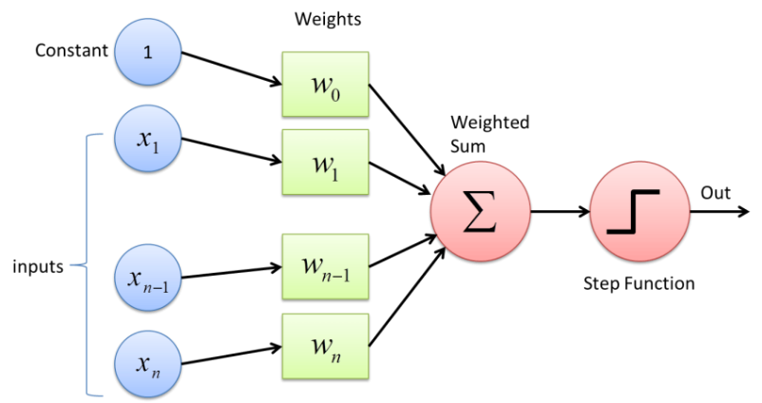

**Working of Perceptron:**The process begins by taking all the input values and multiplying them by their weights. Then, all of these multiplied values are added together to create the weighted sum. The weighted sum is then applied to the activation function, producing the perceptron's output. The activation function plays the integral role of ensuring the output is mapped between required values such as (0,1) or (-1,1). It is important to note that the weight of an input is indicative of the strength of a node. Similarly, an input's bias value gives the ability to shift the activation function curve up or down.

15. What’s the difference between AI and ML?

**Answer:** [**Artificial Intelligence**](https://www.geeksforgeeks.org/artificial-intelligence-an-introduction/)**:** The word Artificial Intelligence comprises of two words “Artificial” and “Intelligence”. Artificial refers to something which is made by human or non natural thing and Intelligence means ability to understand or think. There is a misconception that Artificial Intelligence is a system, but it is not a system .AI is implemented in the system. There can be so many definition of AI, one definition can be “It is the study of how to train the computers so that computers can do things which at present human can do better.”Therefore It is a intelligence where we want to add all the capabilities to machine that human contain.

[**Machine Learning**](https://www.geeksforgeeks.org/getting-started-machine-learning/)**:** Machine Learning is the learning in which machine can learn by its own without being explicitly programmed. It is an application of AI that provide system the ability to automatically learn and improve from experience. Here we can generate a program by integrating input and output of that program. One of the simple definition of the Machine Learning is “Machine Learning is said to learn from experience E w.r.t some class of task T and a performance measure P if learners performance at the task in the class as measured by P improves with experiences.”

**The key difference between AI and ML are:**

|  |  |  |
| --- | --- | --- |
| **S.No.** | **AI** | **ML** |
| 1 | The aim is to increase chance of success and not accuracy. | The aim is to increase accuracy, but it does not care about success |
| 2 | It work as a computer program that does smart work | It is a simple concept machine takes data and learn from data. |
| 3 | The goal is to simulate natural intelligence to solve complex problem | The goal is to learn from data on certain task to maximize the performance of machine on this task. |
| 4 | AI is decision making. | ML allows system to learn new things from data. |
| 5 | It leads to develop a system to mimic human to respond behave in a circumstances. | It involves in creating self learning algorithms. |
| 6 | AI will go for finding the optimal solution. | ML will go for only solution for that whether it is optimal or not. |
| 7 | AI leads to intelligence or wisdom. | ML leads to knowledge. |